**Java Scanner**

1. Scanner class in Java is found in the java.util package. Java provides various ways to read input from the keyboard, the java.util.Scanner class is one of them.
2. The Java Scanner class breaks the input into tokens using a delimiter which is whitespace by default. It provides many methods to read and parse various primitive values.
3. The Java Scanner class is widely used to parse text for strings and primitive types using a regular expression. It is the simplest way to get input in Java. By the help of Scanner in Java, we can get input from the user in primitive types such as int, long, double, byte, float, short, etc.
4. The Java Scanner class extends Object class and implements Iterator and Closeable interfaces.
5. The Java Scanner class provides nextXXX() methods to return the type of value such as nextInt(), nextByte(), nextShort(), next(), nextLine(), nextDouble(), nextFloat(), nextBoolean(), etc. To get a single character from the scanner, you can call next().charAt(0) method which returns a single character.

Java Scanner Class Declaration

**public** **final** **class** Scanner

**extends** Object

**implements** Iterator<String>

How to get Java Scanner

To get the instance of Java Scanner which reads input from the user, we need to pass the input stream (System.in) in the constructor of Scanner class. For Example:

1. Scanner in = **new** Scanner(System.in);

To get the instance of Java Scanner which parses the strings, we need to pass the strings in the constructor of Scanner class. For Example:

1. Scanner in = **new** Scanner("Hello Javatpoint");

Java Scanner Class Constructors

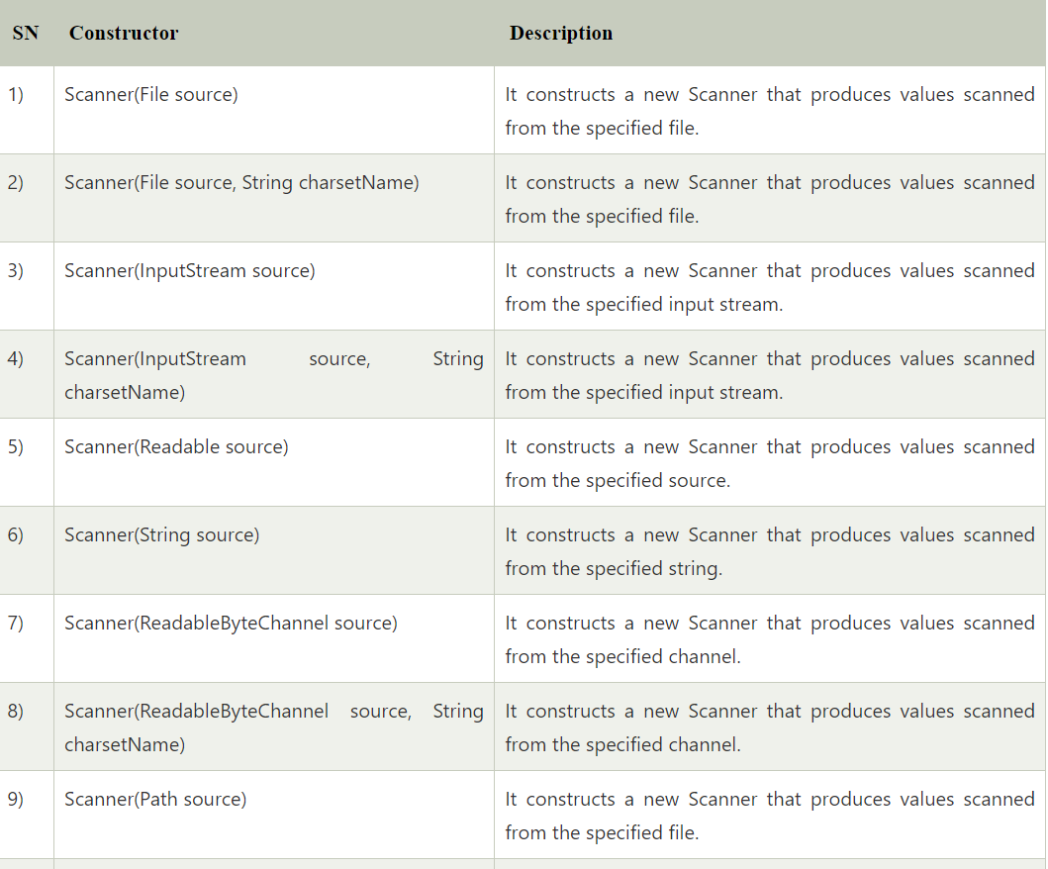

## Java Scanner Class Methods

The following are the list of Scanner methods:

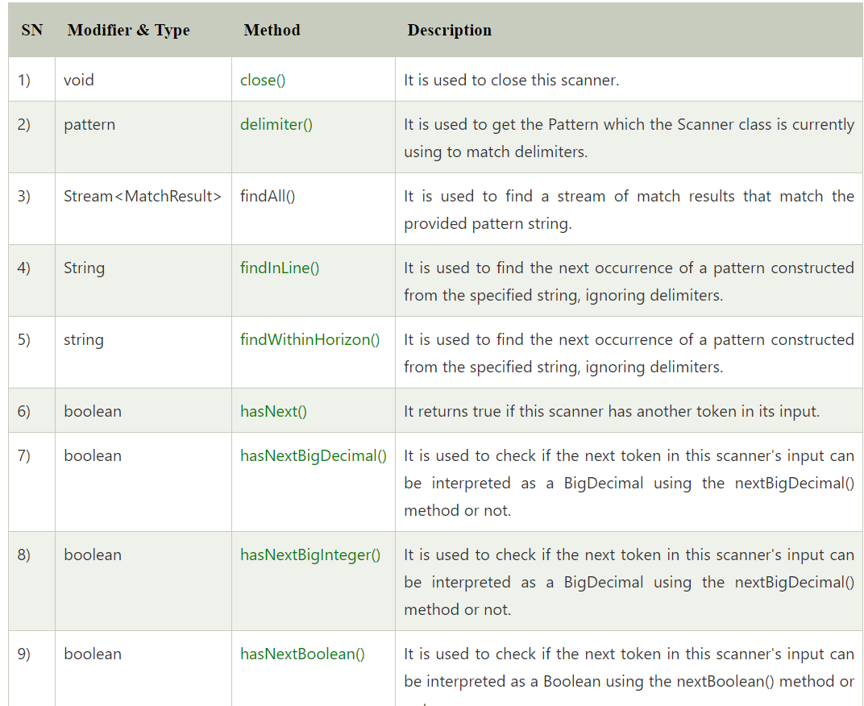

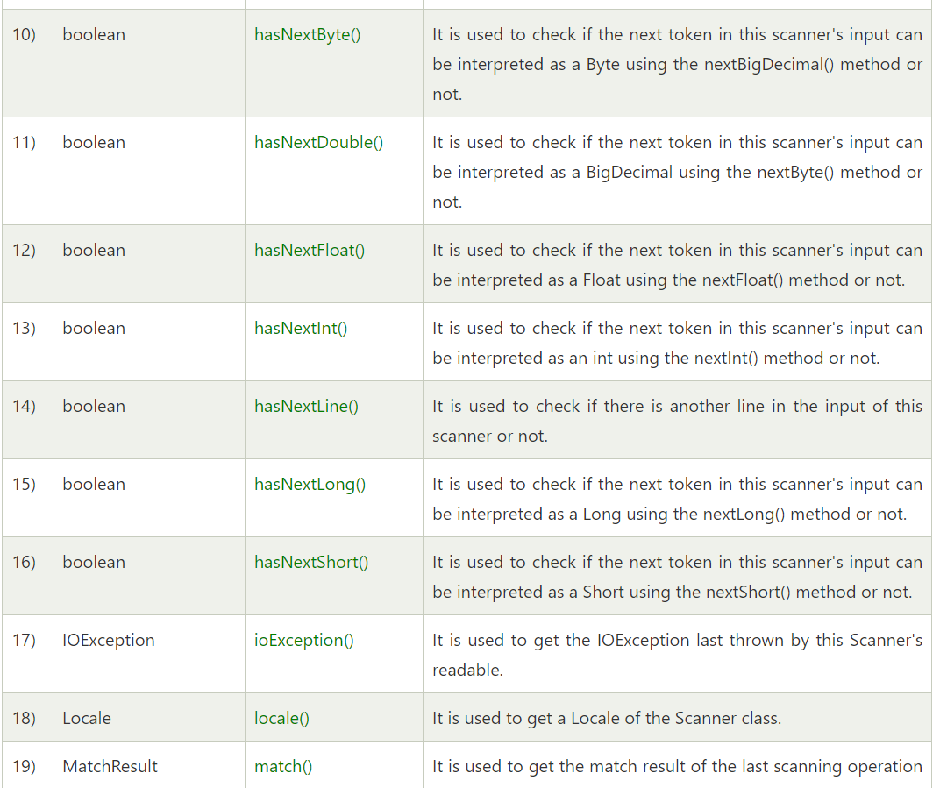

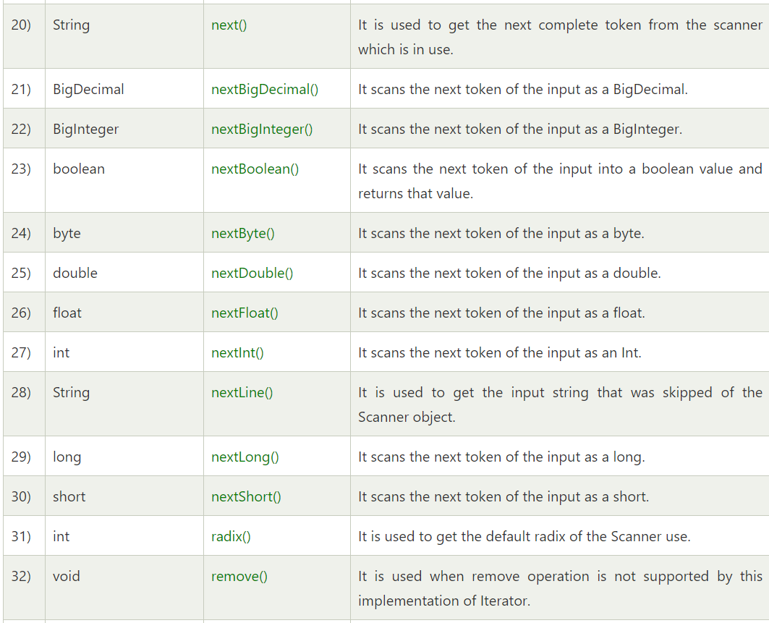

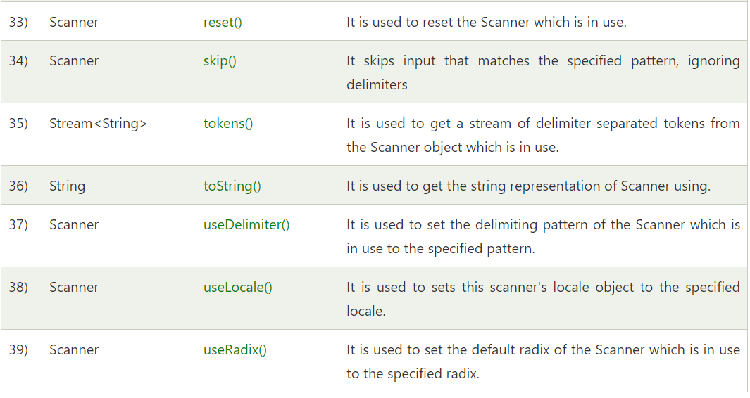

Example

Let's see a simple example of Java Scanner where we are getting a single input from the user. Here, we are asking for a string through in.nextLine() method.

**import** java.util.*;

**public** **class** ScannerExample {

**public** **static** **void** main(String args[]){

Scanner in = **new** Scanner(System.in);

   System.out.print("Enter your name: ");

 String name = in.nextLine();

 System.out.println("Name is: " + name);

   in.close();

          }

}

**Output:**

Enter your name is : Mayuri Nathjogi

Name is : Mayuri Nathjogi